
Project Phase 1-
Database Initial Study
(CMPG311)
Group Members:
[34343962 – K.K. Tshabalala] – (Group Leader)
[35242604 – S.N. Galela]
[36450146 – O.M. Mogajane]
[34496882 – N.T. Yende]
[35834609 – O.K Seloro]
[34585265 – N.N. Jele]

Submission date: 15/04/2022
Table of Contents
Project Phase 1 – Database Initial Study 1
1. Members of the group 1
2. Analyse company situation 4
3. Define problems and constraints 6
4. Database system specification 6

Project Phase 1 – Database Initial Study

- Scenario
Mystique Beaty bar is a Beaty bar that caters to hair, makeup, nails, waxing and facials. The business started up in 2017 as a salon that focused on hair care. Over the years the business expanded on its services. The business added wigs, men’s hair, makeup, nails, waxing, facials, selling wigs, makeup equipment, and hosting nail and makeup workshops. From the start of the business the employees have been using a manual filing system to manage their services. With the increase of services provided, it is causing a strain on their current filing system. The system is hard to keep organized because of all the admin that comes from the services and products. With many businesses going electronic with their filing system, Mystique Beaty bar has decided to go electronic as well. They need database that can store their business’s information.

Members of the group


Kgopolang K Tshabalala (Group leader)
34343962
kgopolang.tshabalala@gmail.com


Oratile M Mogajane
36450146
oratilemapuleng@gmail.com


Nhlanhla N Jele
34585265
nhlanhlanolwazi@gmail.com


Ntokozo T Yende
34496882
Yendentokozo5@gmail.com


Oratile K Seloro
35834609
Oratile.seloro@gmail.com


Sharon N Galela
35242604
Sharongalela24@gmail.com

Analyse company situation

Company objectives (mission of the environment)

- The company is aiming to maximise profit
- To offer different services (such as nails, selling and installing wigs, make-up and etc) to draw in more clients
- To render exceptional customer service and beauty services at an affordable price.
- To upgrade the filing system the business uses.
- To employ more employees as more services will be rendered.

Company operations (general operating environment)

Mystique beauty salon is a unisex salon, which provides a variety of services. It is divided into departments, which offer services like hair, nails, and make-up. The salon also sells products like wigs, and beauty accessories such as make up equipment etc. The salon operates at a first come first serve bases. It opens at 8am and close and 7pm, however customers are accepted until 4pm, because some hairstyles take long.
When the customer gets in the salon, they pick the type of service or product they desire. The salon is currently using a manual filling system, so they write their name, phone number, product, or service they desire, and the receptionist will write down the price. The customer will have to get in a queue and wait their turn. The customer has the liberty to pay cash or card and they pay once they have received the product, or the service has been rendered.
The employees each have a unique service they render, there are hairstylists, make-up artist, nail technicians, receptionist, estheticians and sales personnel. The hairstylists are responsible for plaiting, installing wigs and cutting hair. For example, the hairstylist that installs wigs will not plait cornrows. The make-up artist offers different types of services, such as bridal make-up, matric farewell make-up etc. The nail technicians provide a range of nail styles and shapes. The receptionist is responsible for the administration and the welcoming of customers. The sales personnel are responsible for selling the beauty accessories. The salon also has vacancies for part time jobs, that only open in peak seasons. The part time employees will receive a stipend for the work done.
Each services have a standard price, promotions, and discount. The price of the braids and cornrows differ according to the length, thickness, and hairpiece. The higher the quality of the hairpiece, the longer the length and the less thick the braids are, the more expensive the braids and cornrows. The wig prices differ according to the quality of the hair (Brazilian, Malaysian & Peruvian) and the length in inches. The longer the inches the more expensive. The haircuts are categorised according to fades, brush and chiskop. Fades being the most expensive. If you decide to dye or add a pattern, the price increases. The pricing of the nails varies according to the length, shape (French, coffin etc.) and whether they are gel or acrylic. The make-up pricing depends on the simplicity of the look and the brand chosen. The pricing of waxing depends on the type of wax one wants to do and which body part it should be done. The facial depends on the type of facial chosen.
All employees earn a basic salary according to the service they provide. They earn 15% commission from the amount they charge each customer, the other 85% goes the business account.
The business has different suppliers for wigs, nail equipment, make-up products and beauty accessories. Each supplier has a different delivery date, time, and delivery price.
The salon also offers make-up and braiding tutorials every three months to anyone, who is willing and able to learn.
The stock for wigs, beauty accessories and other inventory, which helps the business conduct a service is managed by the salon staff. The stock is managed by checking if the total stock is equal to the subtraction of the stock bought and sold.
The salon also markets its own products and services and keeps track of the target outreach.
Business rules:
- Employee details must be stored in the database.
- Workshops should be held once every 3 months.
- Workshop type must be specified.
- Full-time employees’ remuneration is the sum of the commission and basic salary.

Company organizational structure …
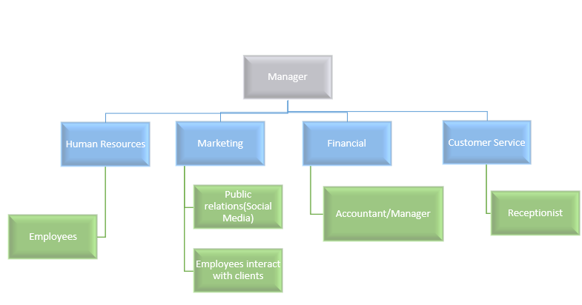

Define problems and constraints
- Problems

- outdated system that was using manual filing is moving to electronic filing
- transitioning from here to a full beauty bar forces the business to create a database
- increase of services increases the prices and it adds to the workload.
- losing track of the workload and/or services

- Constraints

- not having enough money to create the system.
- Employees might reject the system.
- maintenance costs cannot be too expensive
- Not having a lot of time to create system and needs to be done by the end of May
- services need to be affordable.

Database system specification

Define objectives to solve problems identified

- To upgrade the filing system of the business by creating a database in order to store and manage business data.
- Have stock management keeping track of the amount of stock coming in and out of the business to ensure that the business does not run out of stock.
- Make sure that the receptionist caters to walk-in clients and makes sure that client information is jotted down.
- Having an account to handle the bookkeeping and make sure that business is making revenue.
- The manager has to always ensure that the day-to-day operations of the business are going smoothly and that the employees render quality services.

Information that company requires from database

- The database must have enough memory to hold the details of our customers.
- The database should be able to keep track of our suppliers.
- The database should keep track of our available stock and products.
- The database should keep track of the online payments.
- The database should maintain the fast speed whenever there’s increase in data stored.
- The database should have enough memory to store the increase in data.
- The database should keep track of the hours the employees works per day

Scope - "the part of a system that defines the extent of the design according to operational requirements”

The new database system is initially implemented with the aim of assisting the manager and the Beauty Bar employees with the management of finances and stock. The new system will ensure smooth operation of the beauty bar as it will be easy to track the inflow and outflow of money after the services have been rendered, and to track the available stock in the warehouses.

The database will contain details of employees, services offered and the supplier. An employee can only offer one service at a time. Each employee is equipped with a single skill, the beauty bar has the hairstylists, make-up artists, nail-technicians, estheticians and sales personnel. The database will help solve problems that were previously encountered when the file system was used such as loss of important information. Permanent employees of the beauty bar will receive a basic salary plus commission, while the part time employees only get a stipend. Once in every 3 months, a workshop will be hosted by one of the highly skilled employees. The database will be responsible for many processes of the business, from the sales of products, services offered, to supplies management. The receptionist and the manager will handle the processes of the database management system and the security. The database will contain entities such as Full time employees, part time employees, stock management, services & product, supplier, make up, workshop, body care, waxing, facial, nails, braids, cornrows, wigs and etc.

Boundaries - "the external limits to which any proposed system is subjected. (eg. budget, personnel, hardware, software)”

- Additional services must be limited to avoid a straining the system.
- We cannot exceed the budget to create the database.
- There needs to be more than 3 people working on the system and a maximum of 6 people that work on the database.
- The business needs to have the equipment to manage the database.
- The business needs the necessary software to access and interact with the database.

